Carrot Cake ~Doctored Mix Recipe

5/31/2022- This is the original Doctored Cake Mix that has appeared on our site for years. We now have an updated version that is based on a single box of spice cake mix- however, for those of you who still love the original recipe, here it is!

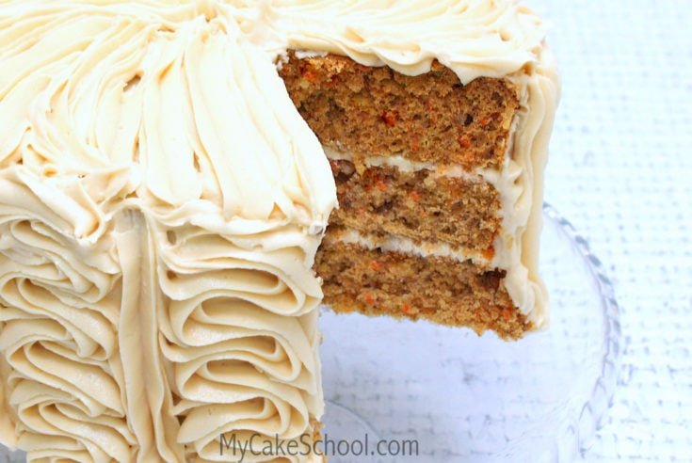
This moist and delicious Carrot Cake starts with cake mixes!

Ingredients
- 1 box spice cake mix
- 1 box white cake mix
- Follow box instructions, substituting orange juice for half of the water.
- 1 teaspoon cinnamon
- 3/4 c. shredded coconut
- 2 1/4-2 1/2 cups carrots, grated fine
- 4 oz. crushed, drained pineapple. (We buy an 8 oz can of crushed pineapple and use about half) put in a strainer to let the excess juice drain out
- 1 cup chopped pecans.

Instructions
Preheat the oven to 325 degrees and prepare three 8 inch cake pans with shortening and a dusting of flour. Line pans with parchment or wax paper.
Mix cake mixes together according to box instructions. Then add remaining ingredients.
Bake at 325 degrees until cakes spring back when touched in the center.
This makes a lot of cake batter. You can bake up and freeze any extra layers, tightly wrapped, or you can half the recipe. If you half the recipe, I would use the spice cake mix rather than the white.
© Melissa Diamond

